PortSwigger Web Security Academy — Proof of Concept

SQL Injection Lab 6

SQL injection UNION attack, retrieving multiple values in a single column
Category | SQL Injection
Lab | Lab 6
Completed By | Security Researcher
Platform | PortSwigger Web Security Academy

Lab Objective
Retrieve multiple values in one column by concatenating them with a separator.

Step-by-Step Exploitation
- Open Burp Suite and configure browser proxy.
- Navigate to the lab URL and identify the vulnerable functionality.
- Intercept the relevant HTTP request in Burp Proxy.
- Send the request to Burp Repeater for analysis.
- Craft and inject the appropriate payload into the vulnerable parameter.
- Forward the modified request and observe the response.
- Verify the exploit was successful as shown in the screenshots below.

Screenshots & Evidence
Lab Solved — Confirmation
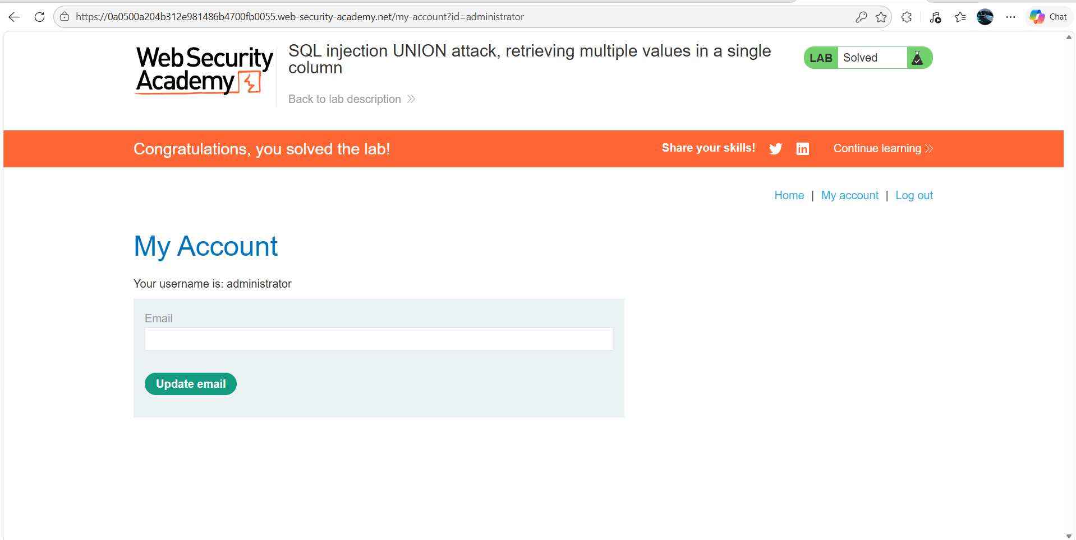
Figure 1: Lab Solved
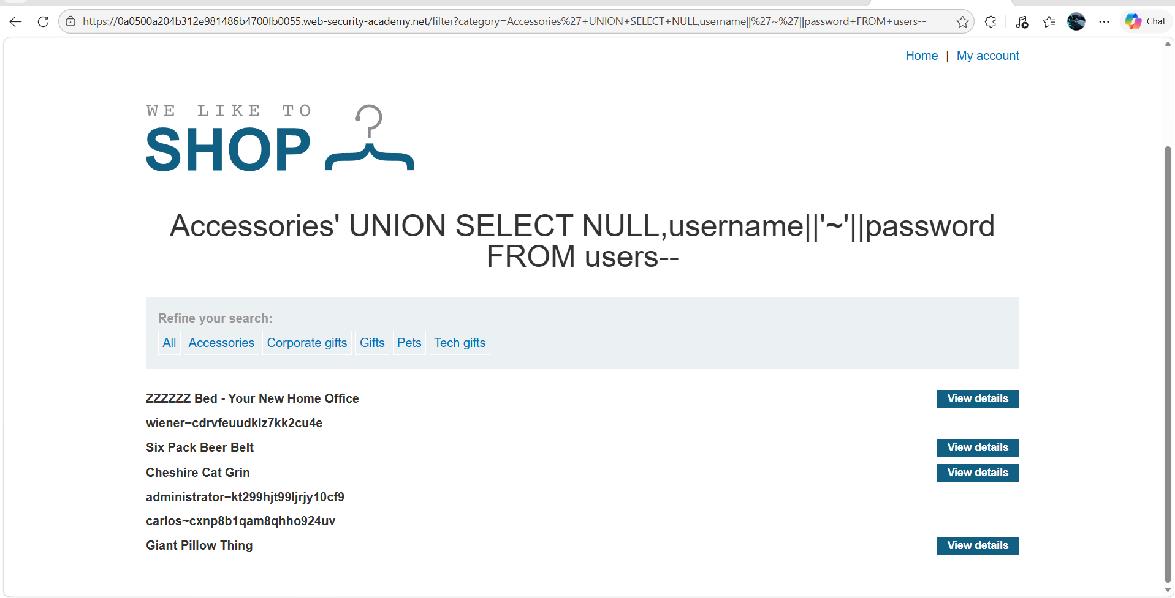
Figure 2: Modify The Url Request And You See The Adminin Password At Bottom
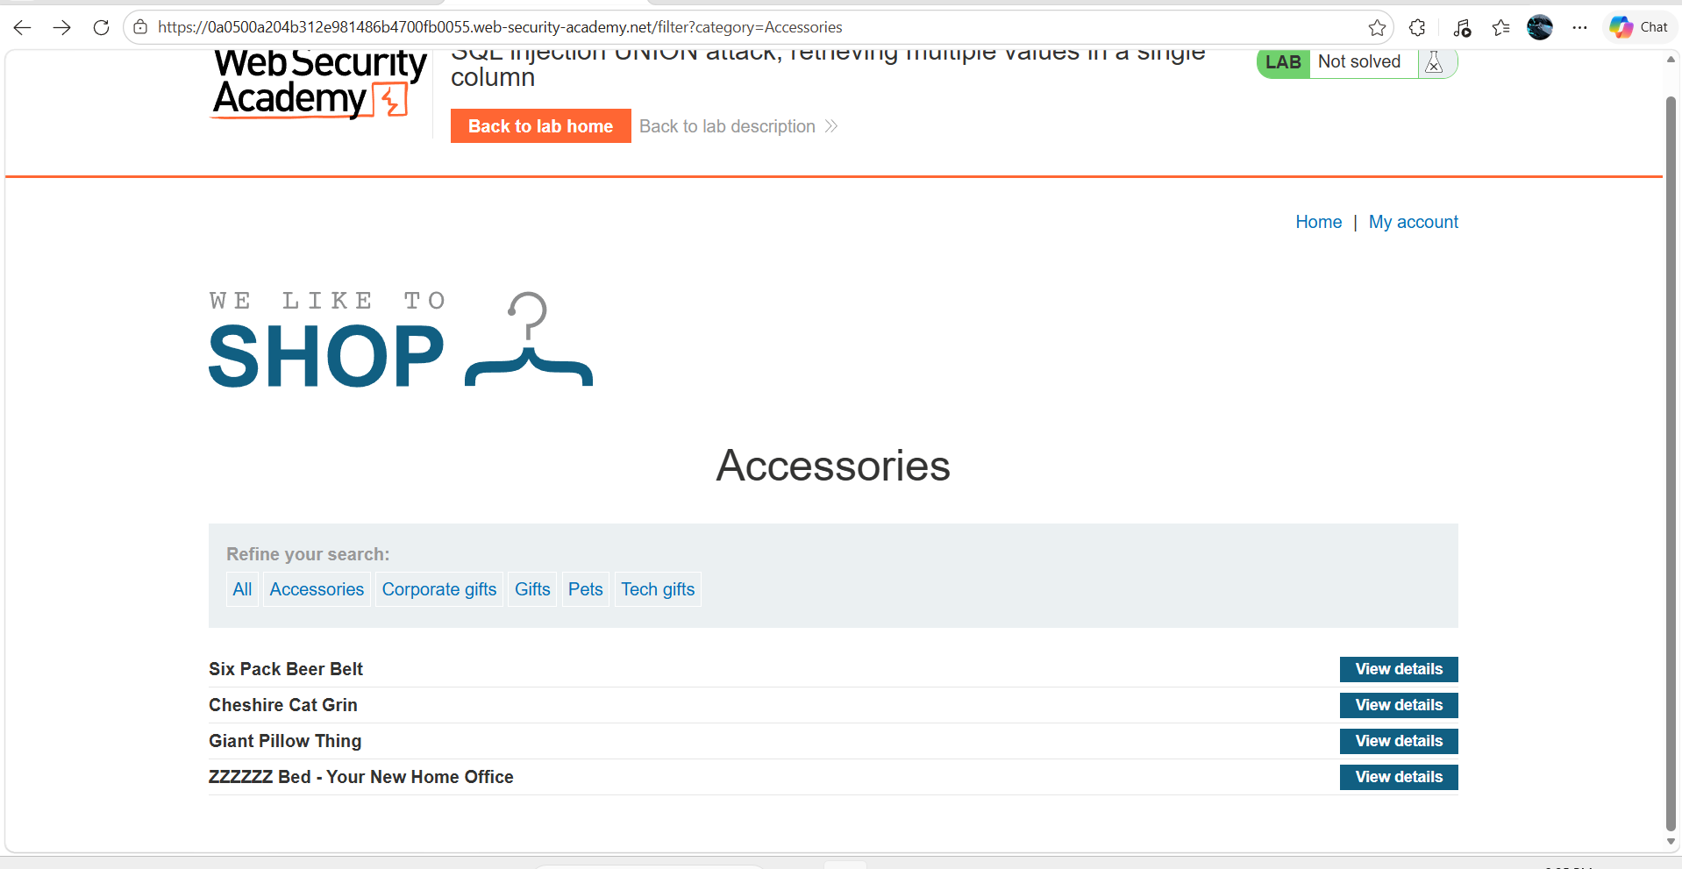
Figure 3: Select The One Catagery

Lab Status: SOLVED

